Warden Monthly Report
STEYNING, BRAMBER AND UPPER BEEDING
APRIL 2024
Hi vis Patrol hours TOTAL: | 81 | ASB incidents TOTAL: |  | 5
Foot - Steyning/Bramber/Upper Beeding | 47 | Noise |  | 0
Vehicle - Steyning/Bramber/Upper Beeding | 34 | Neighbours |  | 0
Notices/warnings TOTAL: | 4 | Driving/vehicles |  | 5
Verbal warning | 0 | Bicycles |  | 0
Parking alert | 4 | Alcohol |  | 0
Yellow card warning (ASB) | 0
Community Protection Warning/Notice | 0
Fixed Penalty Notice | 0 | Clear up/disposal reports TOTAL: |  | 8
Reports into Police TOTAL: | 8 | Fly tipping / flyposting |  | 2
Phone (including 101 and 999) | 0 | Graffiti |  | 1
Online | 2 | Dog fouling |  | 1
Intelligence report | 0 | Litter |  | 2
Verbal | 6 | Drug litter |  | 1
E-CINS (multi-agency reporting) | 0 | Hazards |  | 1
Media Reports TOTAL: | 4
Press release/Community magazines | 1
Social media posts | 3 |  | Community events attended |  | 3
Admin, Training, Meetings & Events | 55 |  | School contact |  | 2
Vulnerable people welfare checks | 5 |  | Youth engagement |  | 15
Signposting | 8 |  | Reports to DVLA |  | 0
Safeguarding referral | 0 |  | Reports to Operation Crackdown |  | 0

ASB crime
Steyning
We were made aware of a ball bearing being fired at a parked car and damaging the window. This was in a private car park along the back of the High Street. We advised that the incident be reported to the police to log the criminal damage. We have been carrying out patrols in the area around the time that the incident occurred as a visual deterrent.
Received a call from a resident in the Penlands Area relating to cold callers, credentials checked.
We have had several reports of electric scooters being used around Steyning. We have advised these incidents to be reported to the police. While on patrol we have noticed a sudden increase and have also passed on the names of people that we recognise using electric scooters to the Police Community Support Officer (PCSO).
A resident informed us of two people that they believe to be involved in drug dealing. This information was passed onto the PCSO.
Words of advice given to 3 young people with electric scooters (Not riding them at the time) on the MPF. Advised that the Police are able to seize the bikes if they will be caught riding them on public Land/Highways.
Bramber
Nothing to report
Upper Beeding
We were contacted by the manager of Nisa regarding suspicious activity in their shop a group of people trying to buy a large amount of alcohol with a card that was declined. We gave the details so that manager could sign up to DISC, which is a new online system specially for shops so that theft and antisocial behaviour can be reported more easily to the police. Information can also be shared with other local shops that are signed up to the system as a preventative measure.
We were made aware of damage caused to the gate at the play park in Upper Beeding. We carried out patrols of the area but have not come across anyone misusing the park. We will continue to keep an eye out for anyone that shouldn’t be in there.
Updates from March
We have contacted the daughter of the vulnerable resident that is acting anti-socially towards their neighbours. Support is in place, we have offered to meet to introduce ourselves and to talk through the problems. We are also in contact with the Housing Manager overseeing the property.
We have not been informed of any more number plates that have been stolen.
Further damage has been caused on one of the gates at Adur Valley Court. A report has been submitted to the police and we have given advice on target hardening the area to deter the behaviour or identify the person responsible. We will continue to include this area on our patrols.
There has been an ongoing issue re the bins at the back of Gris Et Blanc and the Opticians. Allegedly residents nearby are using these bins causing them to overflow. We have sent letters to flats nearby asking people not to use these bins as its beginning to cause an environmental issue.

Parking/vehicles
Steyning
We signposted a resident to report to Operation Crackdown for speeding vehicles going up Bostal Road and made the PCSO aware of what appears to be motorbikes racing up the road on a regular occurrence.
Parking Alerts issued for a car parked on the pavement blocking access to the drop kerb (Church Lane) and for a car parked on the junction of Dog Lane and High Street/Bramber Road.
Bramber and Upper Beeding
Nothing to report.

Fly tipping/littering/graffiti
Steyning
We removed and reported an empty/used cannabis bag from the junction of Reads Walk and Shooting Field.
Fly Tipping reported, Steyning Bostal
Bramber
Fly tipping was reported at two sites along Titch Hill.
Upper Beeding
Graffiti on the bus stop on the High Street was reported and quickly cleared.

Community engagement/events/meetings
We held our monthly board game café. We had a good number of attendees despite having a few apologies for the Easter holidays. Three police officers visited the café and engaged with the people that attended. We also had a vulnerable member of the public speak to us who presented as homeless and had nowhere to stay that night. We made many enquiries with Horsham District Council and Horsham, Worthing and Brighton based charities to try and get him support. He had also lost his phone and card the day before so was unable to pay for a hotel or food. The police officers helped us in trying to locate his lost items, but unfortunately, we were unable to do so. We gave him an emergency pack of food and a foil blanket in case he did have to sleep outside overnight. We signposted him to Worthing Council as he had a local connection there and may be able to get housing support.
Steyning
We attended the farmer’s market. Lots of attendees spoke with us about our role, to enquire about upcoming events or to report issues they had come across.
We hosted the bi-weekly social club at Dingemans, and we also visited the Abbey Road Open Day to show our support.
Bramber and Upper Beeding
Nothing to report.

Patrols (foot/visible and car)
Steyning
High Street
Bus Shelter
MPF
Fletchers Croft
Bramber
Bramber Castle and nearby footpath/train line signs
Botolph’s Church
Upper Beeding
Smugglers Lane
Playing field
Small dole skate park
Beeding Hill/Truleigh Hill
Adur Valley Court

Older, vulnerable people and youth
Steyning
Last month we were made aware of a vulnerable resident acting anti-socially towards their neighbours. We have now spoken with their family members and are arranging a visit so that we can introduce ourselves, our role and to discuss the unwanted behaviour.
The Youth Worker for the Steyning Downland Scheme invited us to speak at an event she had organised with the Police Cadets that had travelled down from Horsham. We delivered an interactive session on vandalism and littering and asked for their input on how to manage sites that face these issues.
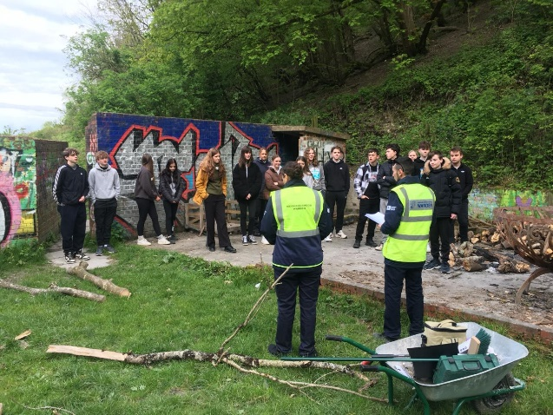
Bramber
Nothing to report.
Upper Beeding
A social prescriber from Henfield contacted us regarding a vulnerable person that needed advice on a large amount of cash that had gone missing. We visited the resident and gave advice, we will be visiting again to check on their welfare.

Dog related issues
Steyning
We were contacted regarding a resident that had found a lost dog. Fortunately, they were able to reunite the dog with the owner.
While on patrol along the footpath between the primary school and Reads Walk we saw a dog walker not pick up after their dog. We caught up with them and asked them to pick it up which they did.
A resident contacted regarding an out-of-control dog (Great Dane) The resident was approached by the dog whilst running and felt very intimidated, she asked the owner to put the dog on the lead and was subsequently verbally abused by the owner. We advised t report to the Police so there is a record, we took a description of the dog and owner to keep an eye out whilst patrolling.
Bramber and Upper Beeding
Nothing to report.

Cycling
Nothing to report.

Parish specific/other
Steyning
We are attending the Vintage Revival.
Bramber
Nothing to report.
Upper Beeding
Nothing to report.

