Warden Monthly Report
STEYNING, BRAMBER AND UPPER BEEDING
FEBRUARY 2024
Hi vis Patrol hours TOTAL: | 68 | ASB incidents TOTAL: |  | 1
Foot - Steyning/Bramber/Upper Beeding | 17/5/12 | Noise |  | 1
Vehicle - Steyning/Bramber/Upper Beeding | 16/6/12 | Neighbours |  | 0
Notices/warnings TOTAL: | 2 | Driving/vehicles |  | 0
Verbal warning | 0 | Bicycles |  | 0
Parking alert | 2 | Alcohol |  | 0
Yellow card warning (ASB) | 0
Community Protection Warning/Notice | 0
Fixed Penalty Notice | 0 | Clear up/disposal reports TOTAL: |  | 10
Reports into Police TOTAL: | 5 | Fly tipping / flyposting |  | 2
Phone (including 101 and 999) | 0 | Graffiti |  | 1
Online | 1 | Dog fouling |  | 0
Intelligence report | 0 | Litter |  | 1
Verbal | 4 | Drug litter |  | 2
E-CINS (multi-agency reporting) | 0 | Hazards |  | 4
Media Reports TOTAL: | 4
Press release/Community magazines | 1
Social media posts | 3 |  | Community events attended |  | 4
Admin, Training, Meetings & Events | 63 |  | School contact |  | 0
Vulnerable people welfare checks | 5 |  | Youth engagement |  | 4
Signposting | 3 |  | Reports to DVLA |  | 1
Safeguarding referral | 0 |  | Reports to Operation Crackdown |  | 0

ASB crime
Steyning
A knife had been found on Mouse Lane and had been left at the police station, but the front office was closed. We took the knife into the police station and contacted the Police Community Support Officer (PCSO) who arranged to come and collect the knife.
We signposted a shop owner to report directly to the police as there has been 3 break ins to a building that is not in use and recommended that this is done for every occurrence. We will patrol the area on our later shifts to deter it from happening again. The time that they are breaking in is unknown, but it is believed to be after dark. We visited with the local PCSO to see where in the building people are breaking into.
We also visited the Co-Op with the PCSO as they have reported a significant number of shop lifting incidents. We are going to have a presence in the shop to try and deter this behaviour.
An allotment user contacted the PC which was then forwarded onto us regarding excessive noise on the MPF. We contacted the resident to obtain more information and will alter our patrols to engage with the group to make them aware of other users of the space and to be considerate of that when playing their music.
We have signposted several members of the public wishing to report incidents at the front desk at the police station to report online or to call 101 for non-emergencies as they have arrived when the office has been closed.
Bramber
Upper Beeding
Updates from January

Parking/vehicles
Steyning
We issued a parking alert on a vehicle for parking too close to the junction on Church Lane (junction with Shooting Field).
An untaxed car was reported to the DVLA for being on the road in King Stone Avenue.
Bramber
A bus had broken down on The Street in Bramber. We helped to direct traffic around the bus until the engineers arrived and could move the bus to a less obstructive position.
Upper Beeding
We signposted a resident to report anti-social use of a vehicle to Operation Crackdown for cars parking on a bend. We will also issue parking alerts if we see vehicles parked dangerously when on patrol in this area.

Fly tipping/littering/graffiti
Steyning
A shop owner contact Horsham District Council (HDC) concerning litter being left in and around their trade waste bins. We were asked to look at the area to see if any target hardening could be put in place and to discuss the issue with the shop owner. People have been seen congregating in this area in the evenings and broken glass has been found. We will factor this area into our evening patrols to assess the situation further and to deter any possible anti-social behaviour (ASB).
Fly tipping was reported on Titch Hill in the layby.
Graffiti and damage to a bus timetable was reported to Compass Travel to replace the cover. This is the bus timetable on Henderson Walk. Update: The bus timetable was repaired and graffiti cleared.
Used drug litter was disposed of:
1 empty cannabis bag (Charlton Street)
Smoking papers/roaches (MPF)
Bramber
Upper Beeding
Fly tipping was reported to HDC for removal on Edburton Road. A large cushion/dog bed had been left.

Community engagement/events/meetings
Our second board games café was a success with 18 people that came by to play games, socialise or to come and ask us questions. We have been able to secure more board games and have been advertising the café.
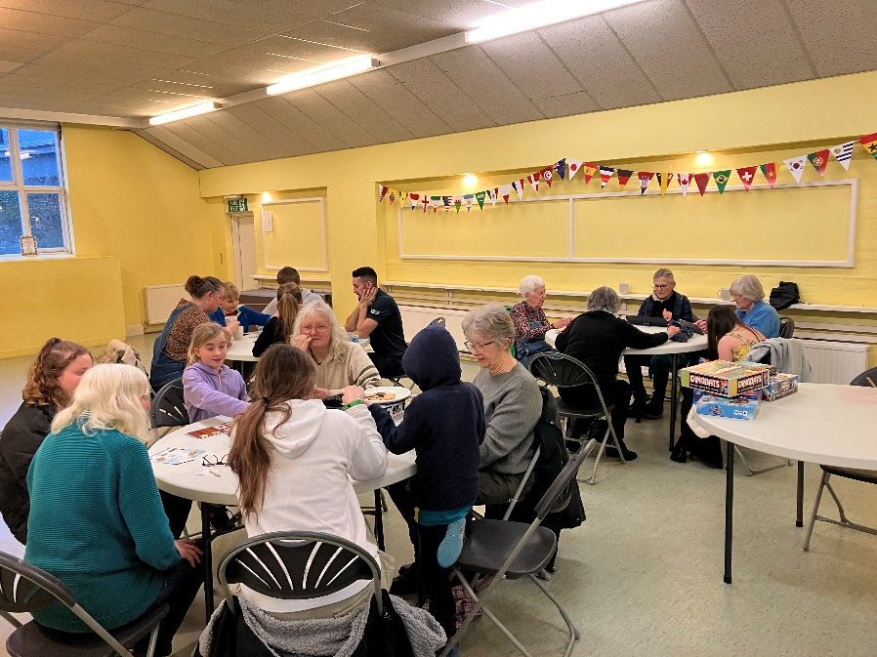
We completed training for HDC on staying safe from Phishing emails and attended the Full Team Meeting where all of the Neighbourhood Wardens for the whole District meet to discuss and share good practice.
Steyning
We were invited to come along to the Vintage Years club to speak to the members and to promote our Bord Game Café. There seemed to be a lot of interest and potential new attendees.
We held two sessions of our social club at Dingemans had a few new people attending. We brought games along, made teas and coffee and served homemade cake made by one of the residents.
The plans for the Community Fun Day that we are running at the Steyning Festival continue and we had another meeting with the organisers to start drawing information together for the programme.
The Dingemans social club continued this month which provides a chance to check in with residents.
Bramber
Upper Beeding
We held a drop-in session at the Repair Café. We spoke to a lot of residents that had attended the café to let them know about our role and to answer any questions they may have. We will be holding our next drop-in session on the 9th of March at the Beeding and Bramber Hall between 2pm and 3:30pm.
Met with Sean Teatum re Dementia Friends & raising awareness locally. We advised we are happy to be involved and support a local campaign and details to follow.

Patrols (foot/visible and car)
Steyning
High Street
Bus Shelter
MPF
Fletchers Croft
Bramber
Bramber Castle and nearby footpath/train line signs
Botolph’s Church
Upper Beeding
Smugglers Lane
Playing field
Small dole skate park
Beeding Hill/Truleigh Hill

Older, vulnerable people and youth
Steyning
There was a group of young people having a disagreement about their bikes. We made sure everything was ok and they went their separate ways.
Bramber
Upper Beeding
From our drop-in session we were made aware of a possible vulnerable resident that may be in need of a welfare check. The condition of the property has deteriorated, and it is unclear if they are still living there or have moved.

Dog related issues
Steyning
Bramber
Upper Beeding

Cycling
Steyning
Bramber
Upper Beeding
Update on issue reported last month re aggressive cyclist, the issue after Police involvement seems to have died down.

Parish specific/other
We attended Parish Council meetings for Steyning and Upper Beeding. We have arranged to attend the Parish Council meeting for Bramber later on in the year.
Steyning
The road sign that shows where the health centre is off of Tanyard Close keeps moving to point in the wrong direction. We have repositioned the sign several times to ensure it is pointing the correct way.
We were contacted by a resident that was looking to donate a tv that they were no longer using and asked if we knew anyone that needed one. We suggested Dingemans as the tv in their communal room has recently broken. We collected the tv and took it over to Dingemans where the manager will have it PAT tested and ready to go. The residents were very thankful for the donation.
An air ambulance landed on the MPF. We checked in with them and offered assistance but were not needed.
Bramber
Remnants of a fire were found in the car park of Bramber castle. The details were forwarded to West Sussex Fire and Rescue for intelligence.
The sign for St Nicholas church next to Bramber Castle was damaged. We reported this to the church for their awareness.
Upper Beeding
Nothing to report

