Warden Monthly Report
STEYNING, BRAMBER AND UPPER BEEDING
JANUARY 2024
Hi vis Patrol hours TOTAL: | 75 | ASB incidents TOTAL: |  | 4
Foot - Steyning/Bramber/Upper Beeding | 17/5/12 | Noise |  | 0
Vehicle - Steyning/Bramber/Upper Beeding | 19/6/14 | Neighbours |  | 0
Notices/warnings TOTAL: | 6 | Driving/vehicles |  | 3
Verbal warning | 0 | Bicycles |  | 1
Parking alert | 6 | Alcohol |  | 0
Yellow card warning (ASB) | 0
Community Protection Warning/Notice | 0
Fixed Penalty Notice | 0 | Clear up/disposal reports TOTAL: |  | 3
Reports into Police TOTAL: | 6 | Fly tipping / flyposting |  | 3
Phone (including 101 and 999) | 0 | Graffiti |  | 0
Online | 1 | Dog fouling |  | 0
Intelligence report | 0 | Litter |  | 0
Verbal | 5 | Drug litter |  | 0
E-CINS (multi-agency reporting) | 0 | Hazards |  | 0
Media Reports TOTAL: | 7
Press release/Community magazines | 2
Social media posts | 5 |  | Community events attended |  | 3
Admin, Training, Meetings & Events | 58 |  | School contact |  | 2
Vulnerable people welfare checks | 4 |  | Youth engagement |  | 5
Signposting | 7 |  | Reports to DVLA |  | 0
Safeguarding referral | 0 |  | Reports to Operation Crackdown |  | 0

ASB crime
Steyning and Bramber
Nothing to report.
Upper Beeding
We were made aware of a cyclist riding aggressively towards staff at the Sports Hall. This information was passed onto the Police Community Support Officer (PCSO) who was able to identify the person responsible and strong words of advice were given.
Updates from December
There have been no further reports of vandalism of the railway signs, ball bearings being fired at houses, electric scooters, or groups causing problems at Fletchers Croft. No further action needed.
We and the PCSOs are continuing their patrols of Bramber Castle and the MPF for cannabis use, we have not received any further reports and have not come across anyone to identify.

Parking/vehicles
Steyning
We were informed by the Horsham District Council (HDC) Communications team that they had been contacted regarding a road safety issue. A Steyning resident has been parking on the grass verge close to a junction. Parking in this close is very restricted. We visited the person that made the initial report and gave advice as they had requested bollards be installed to restrict parking on the verge. This would come down to West Sussex County Council to install this type of thing and we passed on the contact details.
We issued 4 parking alerts to vehicles that were parked on the Church Lane/Shooting Field junction and asked a driver to move their car that was also on the junction.
Bramber and Upper Beeding
Nothing to report.

Fly tipping/littering/graffiti
Steyning
We reported fly tipping on Titch Hill – electrical goods and over 20 bags of dirt and gravel. These were removed by HDC.
Bramber and Upper Beeding
Nothing to report.

Community engagement/events/meetings
Our board game café is up and running and we had a great turn out for our first meeting. It was great to see different generations playing board games together and people bringing their favourites along and learning new ones. Our next board game café is on the 13th of February between 3:15pm and 5:15pm at the Penfold Hall. It is free to come along and we offer free hot and cold drinks.
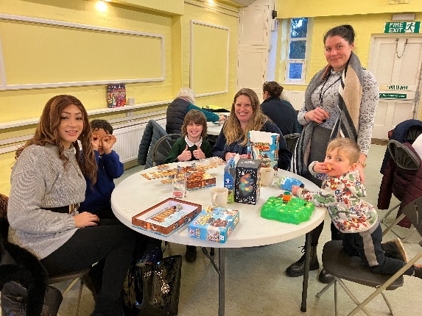
We have been able to advertise our board game café and our Drop-In sessions in the Your Steyning magazine and have been advertising the cafe to raise it’s profile.
Steyning
The Steyning Festival is being held in May this year and we have been asked to get involved. We will be holding a community day on Thursday the 30th of May between 12-4pm. We attended a meeting to provide updates on the activities we have organised and to formalise plans.
Bramber
Nothing to report.
Upper Beeding
We held a drop-in session at Beeding and Bramber Village Hall at the repair café. Lots of residents spoke with us about our role, our initiatives and how to report to us. We were also made aware of fly-tipping issues and nuisance parking. Our next drop-in will be on the 10th of February between 2pm and 3:30pm. We signposted residents to Operation Crackdown and to our board games café.

Patrols (foot/visible and car)
Steyning
High Street
Bus Shelter
MPF
Fletchers Croft
Bramber
Bramber Castle and nearby footpath/train line signs
Botolph’s Church
Upper Beeding
Smugglers Lane
Playing field
Small dole skate park
Beeding Hill/Truleigh Hill

Older, vulnerable people and youth
Steyning
We received a report of a person that was in poor condition sitting in a doorway off of the High Street in shorts. We advised the resident to call for an ambulance and we attended as soon as we were able to. We relieved the residents that had very kindly brought blankets, coats and a drink and stayed with the person. We called the ambulance to provide them with an update on their condition and the ambulance arrived soon after. A relative also arrived and were able to take the person into their care. We were able to catch up with the person the following day and they were feeling better and thanked us and the other residents for helping.
We stopped by the Wednesday coffee morning at eh Penfold Hall to speak with those attending and we handed out leaflets for our board games café.
We continue to run our Social club for the residents at Dingemans.
Bramber and Upper Beeding
Nothing to report.

Dog related issues
Steyning
A resident emailed us regarding an animal welfare issue. They had witnessed a person acting aggressively towards their dog. We strongly recommended they report what they had seen to the RSPCA. We asked for more details and will keep an eye out on our patrols in case we see something similar, and we will report to the RSPCA as well.
Bramber and Upper Beeding
Nothing to report.

Cycling
Nothing to report.

Parish specific/other
We visited the high street shops with the local PCSO’s and signed a further 5 shops to DISC. This is the new system for identifying and reporting shoplifting.

