Warden Monthly Report
STEYNING, BRAMBER AND UPPER BEEDING
MARCH 2024
Hi vis Patrol hours TOTAL: | 69 | ASB incidents TOTAL: |  | 3
Foot - Steyning/Bramber/Upper Beeding | 15/4/11 | Noise |  | 0
Vehicle - Steyning/Bramber/Upper Beeding | 19/6/14 | Neighbours |  | 1
Notices/warnings TOTAL: | 4 | Driving/vehicles |  | 2
Verbal warning | 0 | Bicycles |  | 0
Parking alert | 4 | Alcohol |  | 0
Yellow card warning (ASB) | 0
Community Protection Warning/Notice | 0
Fixed Penalty Notice | 0 | Clear up/disposal reports TOTAL: |  | 2
Reports into Police TOTAL: | 8 | Fly tipping / flyposting |  | 1
Phone (including 101 and 999) | 0 | Graffiti |  | 0
Online | 3 | Dog fouling |  | 0
Intelligence report | 0 | Litter |  | 0
Verbal | 4 | Drug litter |  | 0
E-CINS (multi-agency reporting) | 0 | Hazards |  | 1
Media Reports TOTAL: | 5
Press release/Community magazines | 1
Social media posts | 4 |  | Community events attended |  | 3
Admin, Training, Meetings & Events | 52 |  | School contact |  | 5
Vulnerable people welfare checks | 6 |  | Youth engagement |  | 3
Signposting | 5 |  | Reports to DVLA |  | 0
Safeguarding referral | 0 |  | Reports to Operation Crackdown |  | 0

ASB crime
Steyning
We signposted a resident to Crimestoppers who wanted to report drug dealing but wanted to remain anonymous.
A resident spoke with us regarding a vulnerable neighbour that had started to act anti-socially. We advised they keep a diary of any incidents of ASB that they experience and to contact the police. We contacted Saxon Weald to speak with the officer managing the affected properties.
Damage had been caused by someone thought to be firing ball bearings with a catapult at a glass window just off the High Street. The shop owner reported this directly to the police and made us aware of some other similar incidents that have happened recently in Steyning.
Bramber
A resident made us aware of number plates that were stolen from their car on The Street. This had already been reported directly to the police.
Upper Beeding
We were contacted regarding a gate that is repeatedly being vandalised at Adur Valley Court. We had a look at the gate to determine the damage and will patrol the area and advised the person reporting to submit a police report for vandalism and criminal damage. We asked the PCSO for CCTV signs so they can be displayed to deter any further damage.
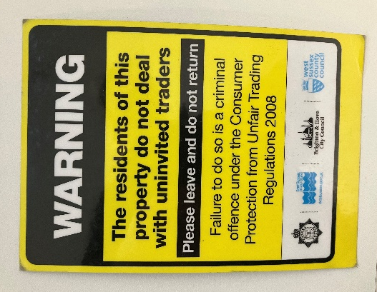
We were notified of cold callers in the Kings Barn Lane and Goring Road area offering to clean driveways and roofing. For one resident, they started cleaning the roof before the work had been agreed. Luckily, the resident was able to stop them from continuing with the work and got them to leave. Please contact us if you would like a sign deterring doorstop traders and cold callers.

Updates from February
Following a visit to the Co-op last month with the Police Community Support Officer (PCSO) we were asked to carry out some targeted patrols through the shop between 8:30 and 9:00 am as some school students had been stealing from the shop. We stayed visible in the shop and based on the feedback from the shop assistants, there was a lot less theft that occurred while we were present due to the visual deterrent. We arranged a meeting with the pastoral team at Steyning Grammar to identify the students involved so that steps can be made to stop this from happening. We notified the PCSO who also attended this meeting. We have requested the manager upload images using the DISC system and to contact the pastoral team at the school if they need to identify any students in uniform as the school will then be able to step in as well whether this be with support or sanctions.
On a routine joint visit to Co-op with PCSO Bicknell we were advised that two young females had stolen 5 bottles of wine the previous evening. Whilst checking CCTV footage a member of staff spotted the same two females in the store. We challenged them and obtained name and address details. They have now been banned from the store. We requested that the manager at Co-op upload images and incident using the DISC System.
We have not been made aware of any more break ins at the Ukraine refuge. However, we believe tiles have been stolen from the roof but are yet to speak with the manager of the site as this has not been reported to us directly.
We have not had any further reports of noise coming from the MPF/allotments.

Parking/vehicles
Steyning
We issued parking alerts on vehicles for being parked to close to a junction on Bramber Road and Tanyard Lane.
Bramber
Nothing to report.
Upper Beeding
We were contacted by the primary school to report problems with drivers parking on double yellow lines. A resident had also informed us of cars being parked on the bend on School Road/Church Lane. We carried out after school patrols and issued 3 parking alerts for the likes of parking too close to the junction, parking on a bend, parking on double yellow or single yellow lines. We also spoke with 2 drivers and asked them to move their cars after pointing out the issue of where they had parked and they did so with no problem.

Fly tipping/littering/graffiti
Steyning and Bramber
Nothing to report.
Upper Beeding
Fly tipping was reported to us, items had been left on the road along from Smugglers Lane. We reported the items to Horsham District Council for removal.

Community engagement/events/meetings
We attended the steering group meeting to discuss our objectives and if the Parish Council priorities are being met.
We held our board game café at the Penfold Hall. Another great turn out with a group of regular attendees and some new faces. The next one is on the 9th of April. We were also joined by Beth, a youth worker from the Steyning Downland Scheme who was available to speak with young people and parents about activities they are also running. The café is open to all ages. Knowing we would be at the Penfold Hall, a resident came to speak with us about an issue they had experienced and needed some advice over regarding a parking dispute. We have contacted the primary schools ahead of the Easter Holidays to promote the April café as a free activity to do during the holidays.
Steyning
We attended the coffee morning at the Penfold Hall on a Wednesday. We spoke with members of the group, and many asked about attending our board game café. We also had requests for the doorstep traders warning signs and have dropped off as needed, we were also asked for advice regarding a chest of drawers that are no longer needed. We visited the resident to see what the best course of action would be and assisted by contacting Fresh Start to see if they could collect the drawers. A lot of the members that attended asked for a general update on community safety in SBUB and were pleased with the current standings.
The manager at Dingemans has given us the go ahead to start putting the games room into action using the funding we have acquired. We met with her to discuss the logistics of purchasing the new equipment and having it installed.
Bramber
Nothing to report.
Upper Beeding
We held a drop-in session at the Repair Café at Bramber and Beeding Hall. It was a quieter day in general, probably due to the good weather, but we did receive reports of cold callers the previous day and offered support to a resident supporting a loved one with dementia.

Patrols (foot/visible and car)
Steyning
High Street
Bus Shelter
MPF
Fletchers Croft
Bramber
Bramber Castle and nearby footpath/train line signs
Botolph’s Church
Upper Beeding
Smugglers Lane
Playing field
Small Dole skate park
Beeding Hill/Truleigh Hill

Older, vulnerable people and youth
Steyning
The Ashington Wardens contacted us as they had come across two young people that were squirting ketchup on cars. We were able to identify the two people and also raised this incident in a meeting we had with the Pastoral Care lead at Steyning Grammar. We were able to speak with one of the young people involved about their choices and how their behaviour needs to improve. As a means of early intervention, we will be discussing this young person with the Anti-Social Behaviour Case Worker for Horsham District Council.
Following our meeting at Steyning Grammar with the Pastoral Care team, we were able to identify a young person that had just started to come to attention. The following day we saw him, and he was calling out at us as we drove past. We simply used his name to say hello which obviously shocked him. The following day he spoke with Mike and had a reasonable conversation, which was an improvement in the behaviour he had been expressing.
We held our club at Dingemans for the residents to encourage the residents to get to know each other and to give them a chance to talk with us should they have any community safety issues.
Bramber and Upper Beeding
Nothing to report.

Dog related issues
A resident informed us of an illegal dog breed; we advised that this is a Police matter and encouraged them to report it.

Cycling
Nothing to report.

Parish specific/other
Steyning
The front office of the police station was not opened at the advertised time. We were in the police station so were able to help 2 people that had come to hand in some items. One item was a backpack that contained an epi pen and a person’s ID that was found in their recycling bin. The other was a decorative sword that the owner had wanted to dispose of. We took both items and the details of the owners, we made sure they were stored securely and notified the PCSO.
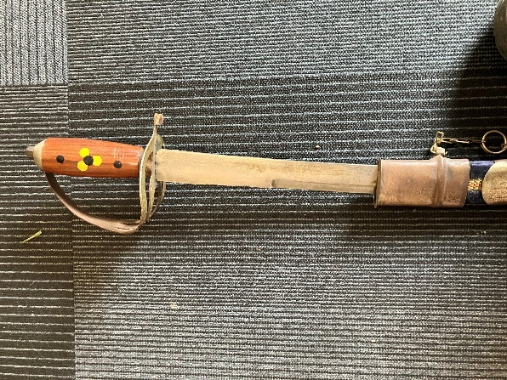
There was an old saw that was in the road on Bramber Road. We retrieved it and disposed of it as it had been damaged from being driven over.
Bramber and Upper Beeding
Nothing to report.

